Memory hotplug-in porting to Kernel 5.4

Application Solution

Exported on Jul 13, 2022

Table of Contents

1 Background 3

2 Assumption 4

3 Short summary 5

4 Detail information 6

# Background

In the current architecture, SYS domain will initialize the whole IVI domain memory as well while booting up because there may be required to support PV driver between SYS and IVI domain.

But customer would like to improve Boot KPI by delaying memory initialization of Android memory when SYS domain is booted up and under investigation regarding no-map and memory hot-plug.

No-map and hot-plug are Linux OS features. Therefore, Samsung can share our investigation & experience, but it does not guarantee correct functionality.

# Assumption

There are PV drivers which access memory allocated to IVI domain as well as PMEM, such as vion, vdmaheap, vbd2..

Hotplug-in must be done before these PV drivers access it.

# Short summary

Customer tried to hotplug-in memory after boot by entering command manually with sysfs provided in kernel hotplug driver.

* echo 0xa40000000 > /sys/devices/system/memory/probe

Above sysfs command will let kernel in sys domain treat the memory as kernel own memory by hotplug-in but the memory is owned by IVI domain.

Therefore, it's required to control more precisely by implementing additional hotplug driver

# Detail information

* It is to improve boot KPI by initializing defined memory after kernel boot.

* In virtualization, memory imported by other VMs should be hotplugged-in as not allocated to buddy (reserved memory).

* Please refer to the Test driver (is going to be shared by sidong park) and device tree. The scenario is for 0x880000000 - 0x900000000 memory region (IVI) is hoplugged in after boot.



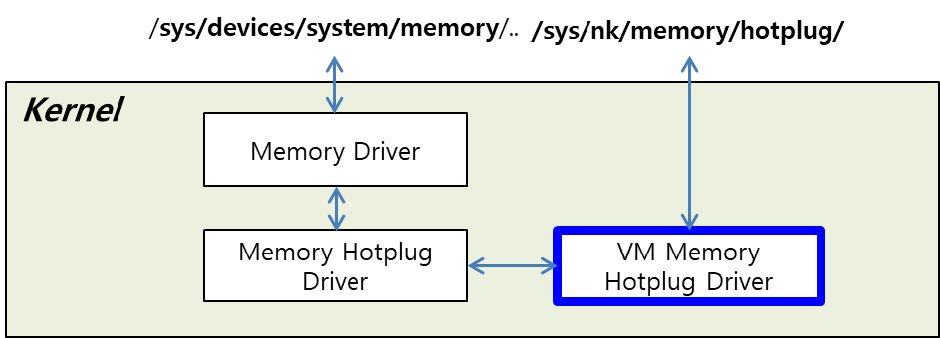

1. Implementation of VM memory hotplug driver (the **blue box** in the picture)
   1. Memory hotplug driver provides API in Kernel.
      1. The table has APIs provided in Kernel 5.4

|  |  |
| --- | --- |
| API | Driver |
| set_online_page_callback() | mm/memory_hotplug |
| restore_online_page_callback() | mm/memory_hotplug |
| add_memory() | mm/memory_hotplug |
| register_memory_notifier() | drivers/base/memory |
| unregister_memory_notifier() | drivers/base/memory |

* 1. Sequence
     1. Depending on whether hotplugged memory is for own or other VM, online_page_callback() should be changed with **set_online_page_callback()/restore_online_page_callback() API.**
        1. online_page_callback() is invoked whenever any page is online.
        2. Own memory is hotplugged in: As default, generic_online_page() function is attached to online_page_callback() and it makes the page allocated to buddy.
        3. Memory imported by other VM is hotplugged in: kind of null function is attached to online_page_callback() with set_online_page_callback()
     2. Memory pages are added with **add_memory() API.**
        1. Note that /sys/devices/system/memory/auto_online_blocks should be set to online, which makes pages online automatically.
           1. echo online > /sys/devices/system/memory/auto_online_blocks
     3. (option) To check out whether the page (which is requseted to be added) is online well, you should register a handler to memory_chain with **register_memory_notifier() API.**
  2. Interface
     1. sysfs should be exposed to user. For example like the test driver,
        1. /sys/nk/memory/hotplug/probe

1. How to configure hotplug memory region
   1. Hotplug memory should have 'no-map' property.
      1. sources/linux_sys_dts-la/linux_sys/exynosauto9-sadk-en-common.dtsi

|  |
| --- |
| **&reserved_memory {       vm-memory@3 {             compatible = "vl,vm-memory";             import;             reg = <0 0x0 0x0>;             vl,vm-id = <3>;       };**        skip-mem {             reg = <0x8 0x80000000 0x80000000>;             no-map;        };  } |

(0x880000000 - 0x900000000 : memory region (IVI) hoplugged in after boot)

* 1. VM memory hotplug driver should know Android memory hotplug region.
     1. (option 1) Device tree node
        1. sources/linux_sys_dts-la/linux_sys/exynosauto9-sadk-en-common.dtsi (example)

|  |
| --- |
| **vm-memory-hotplug-3 {      compatible = "vm-memory-hotplug";      reg = <0x8 0x80000000 0x80000000>; };** |

* + - 1. Probe function is implemented in VM memory hotplug driver.
    1. (option 2) Hardcoding to VM memory hotplug driver